25 February 2015

MEMORANDUM FOR: Russell D. Fendick, U.S. Army Chemical Materials Activity (CMA)

Subject: Drilling and Accessing SVM-14-196 (75mm) and APG-14-590 (4.2 inch mortar) as MAPS.

The SVM-14-196 (75mm) and APG-14-590 (4.2 inch mortar) were removed from the N-Field bunker on 12 February 2015 and taken to the Munitions Assessment and Processing System (MAPS) Facility for the extraction of chemical fill.

- SVM-14-196 (75mm)

The 75mm munition is approximately 90% full of solid material. Based on PINS analysis, the fill was determined to be magnesium arsenide. This fill quantity equates to about 630 grams (approximately 1.4 lbs) based on historical documentation. This munition was not fuzed and contains no energetics.

The munition was removed from the MRC and placed in glovebox “A”. While in glovebox “A” the munition was removed from the plastic bags and transferred to glovebox “B” for installation on the drill trolley and then placed in the drill box. The munition was drilled and sampled. A total of four holes were drilled into the munition at 90 degree angles to each other to demilitarize the munition. Approximately 8 grams of magnesium arsenide was removed and placed in a sample bottle. The holes were plugged with a wax plug, wrapped with duct tape, and repackaged into the original MRC. The sample was taken to ECBC Environmental Chemical Monitoring Laboratory for characterization by Brain Maciver. The munition/MRC was placed back in the N-field bunker until it can be disposed of at the appropriate waste facility.

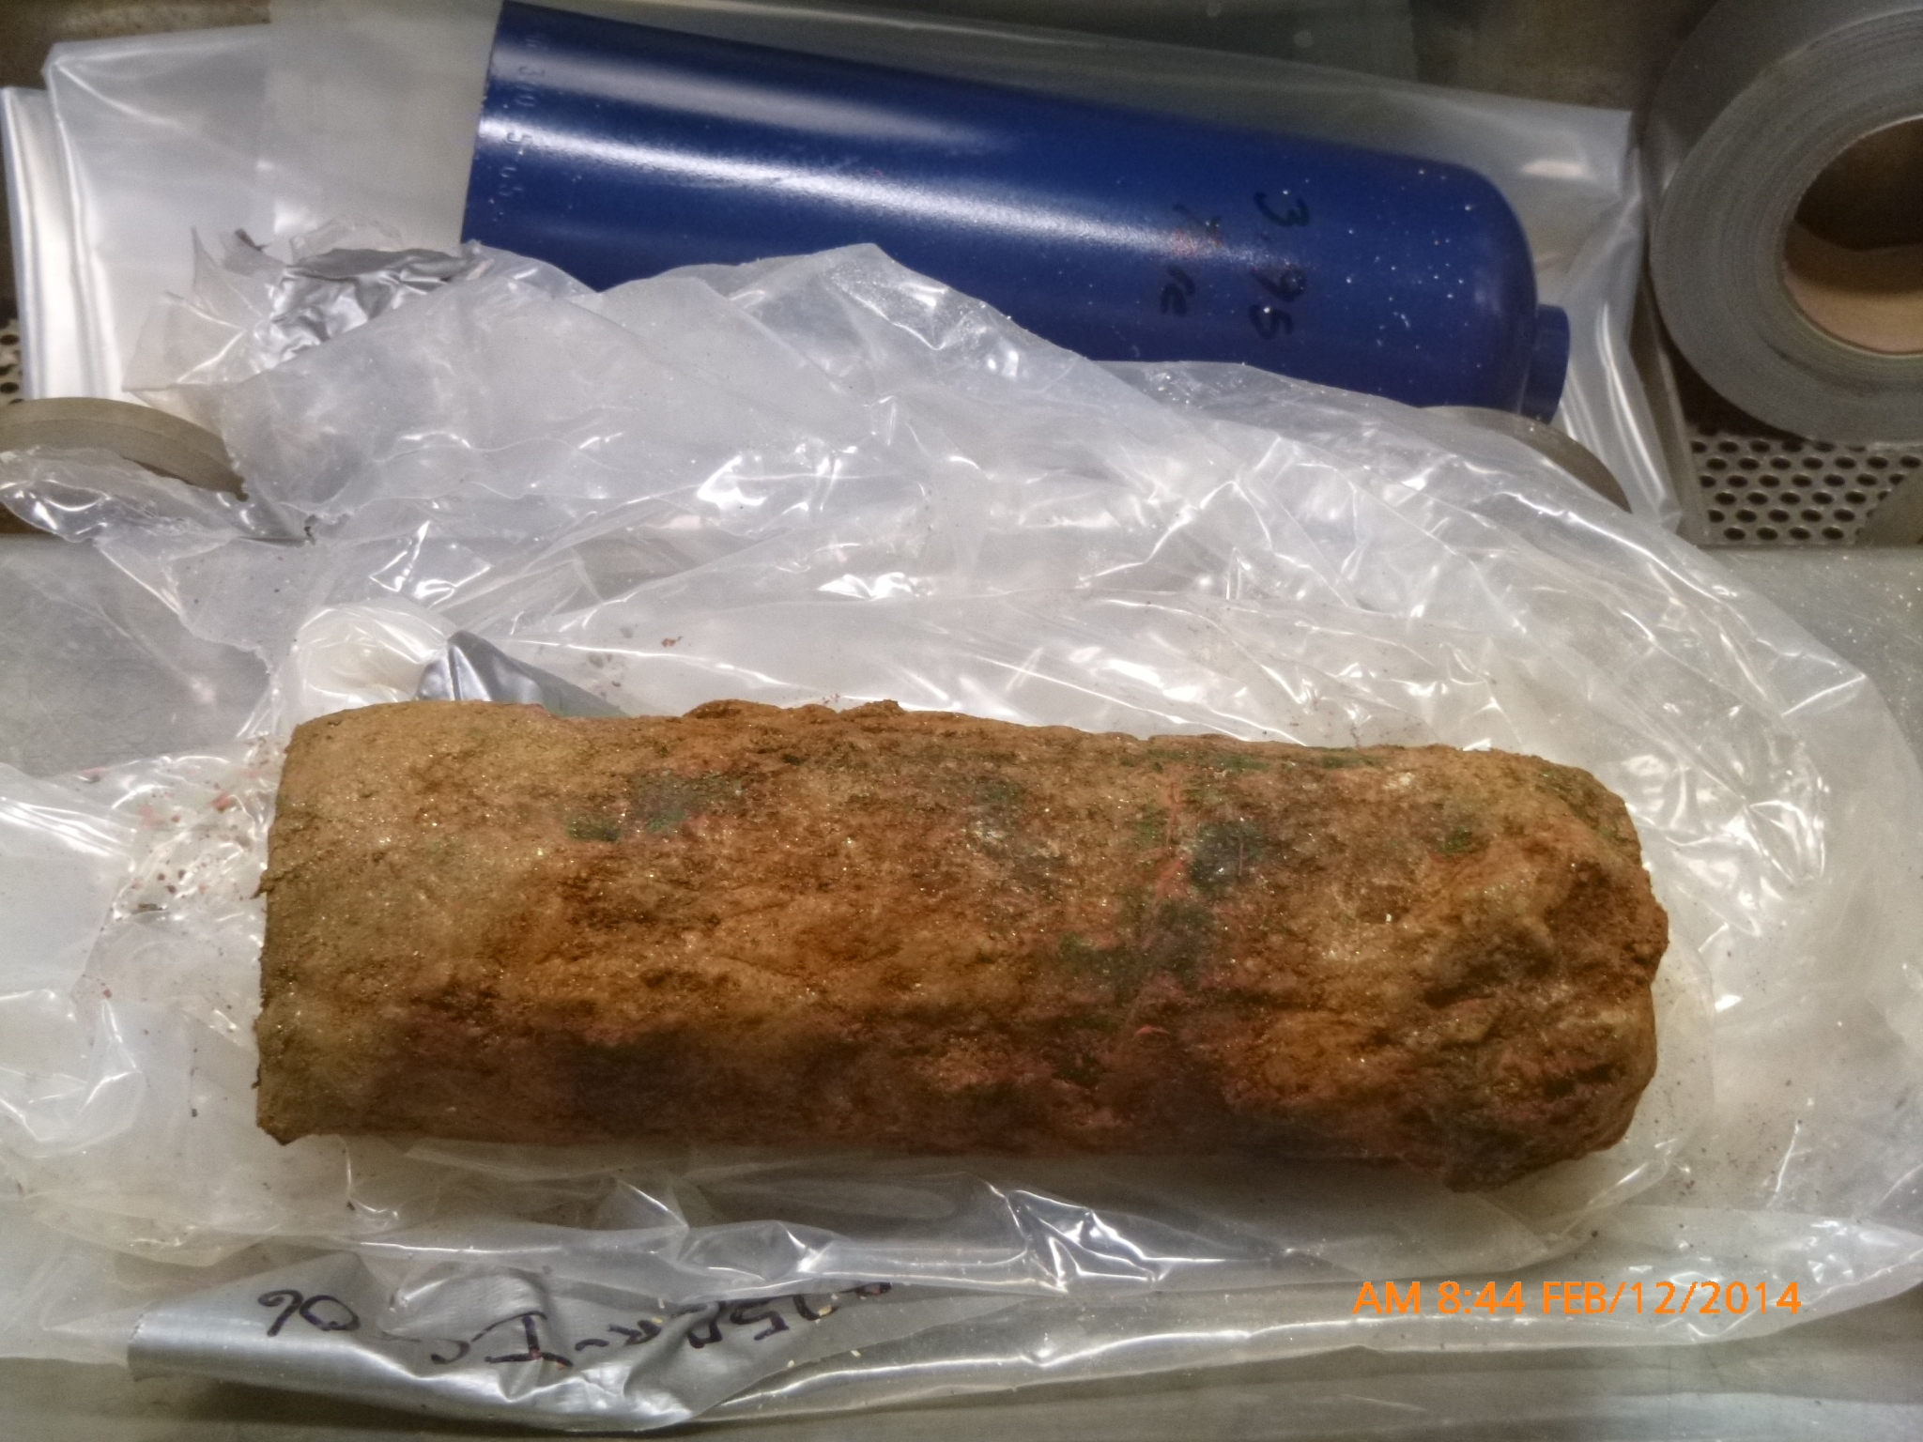
75mm removed from plastic bags

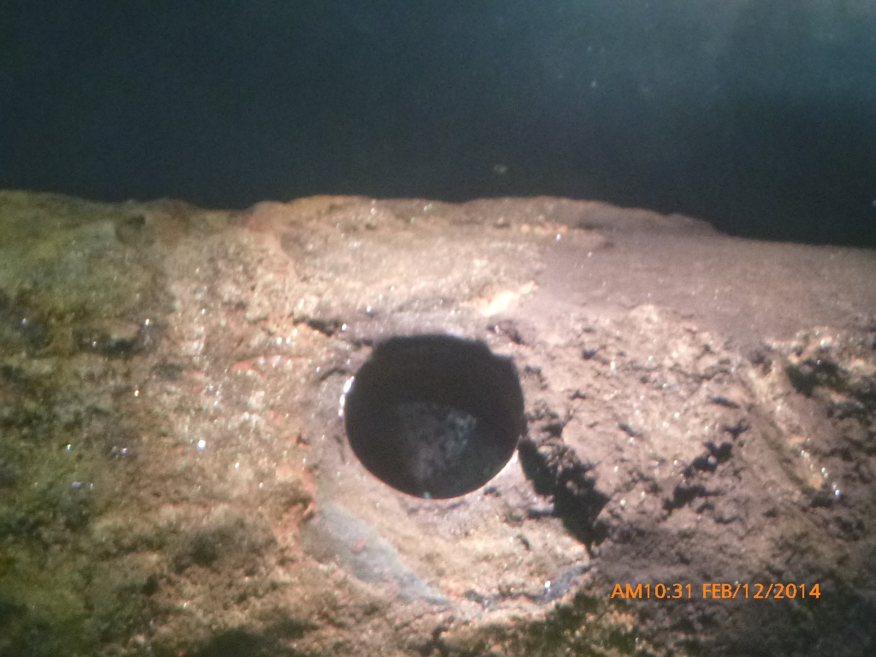
One of the holes drilled into the munition for sample removal.

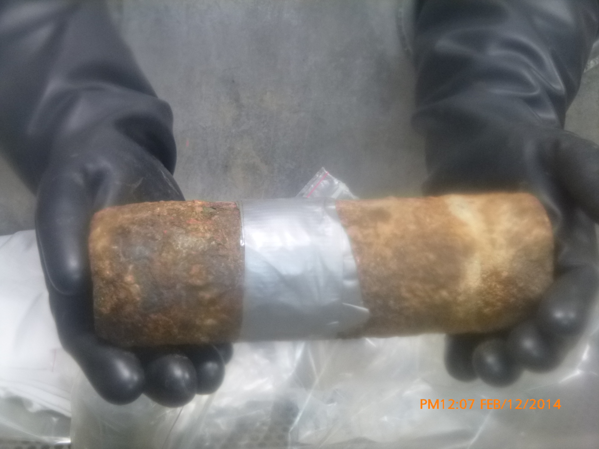
Munition prior to repackaging.

- For additional information on this please contact Cheryl Kyle at 410-436-6992 or Worthy Hollister at 410-436-6206.

Cheryl Kyle
Program Manager
ECBC – CBARR

